Project#5: MENTOR New York Career Readiness Fellowship Program
Project Abstract
Project Goal
Designed, developed, and managed the MENTOR New York Career Readiness Fellowship Program for undergraduate and graduate first-generation students to develop soft skills and professional networks.
DEL Outcomes
2 and 5
Competency Areas of Focus
Organizational Dynamics
Accelerated Leadership Development
Complexity and Sustainability
Project Overview
During the pandemic, college students, especially first-generation students, did not have access to internships at the same rate as in the past. The National Foundation Study of Online Internship by the Center for Research of College- Workforce Transitions at UW- Madison (2021) found that 1 in 5 students engaged in internships during the summer of 2020. The students were from upper-income families, had higher GPAs, and were not likely to be first-generation college students. In the summer of 2021, even though there was an uptick in intern engagement, studies show there is still a gap between first-generation Latinx and Black students.
This gap leads to significant workforce inequities as students who secure internships during their college careers are on track to have full-time employment upon graduation. According to Braven(2021)," A NACE survey found that students who had internships were 20% more likely to receive full-time job offers than students who did not complete an internship". They also found that those with internship experience were 14% more likely to get an interview and often had mentors they found during internships, allowing access and social capital to secure future employment (Braven, 2021).
Longstanding academic and social setbacks emerge as the pandemic "winds down," and young people return to more familiar everyday routines. Both federal, state, local, and private industries are investing in helping close established gaps. Recently, MENTOR New York received funding from a corporate foundation to create and implement MENTOR New York's Career Readiness Fellowship to help colleges at the undergraduate and graduate levels begin to build the social capital they may have lost in not engaging in an internship the past two years. The corporate funding provided to MENTOR New York allowed for piloting a new program to learn more and develop emerging practices for future fellowship programs focused on similar outcomes. This safe-fail funding opportunity has allowed MENTOR New York to experiment, learn and test new ideas and initiatives in response to emerging realities. (Snowden, 2016). This project focuses on DEL program outcomes 2 and 5. The focus areas include accelerated leadership development, organizational dynamic, and collaborative leadership.
Project in Action
MENTOR New York is not an expert in understanding the barriers that limit persistence in higher education for first-generation students and the challenges to developing the soft skills and professional networks that can help their development and career trajectory. Therefore, the first step in the process was to create a Higher Education Advisory Council of Administrators to inform the fellowship's need, design, and recruitment strategy. These leaders have become the champions of our work, and the collaboration will yield future projects to elevate our efforts to support first-generation Latinx and Black Students. This cross-enterprise partnership allows for sharing knowledge and leveraging the importance of our key customers, first-generation college students( Siggelkow & Terwiesch, 2019).
With the council's guidance, data on student needs, and an understanding of the pressures of a college student's schedule, MENTOR New York designed a fellowship that provided participatory 90-minute sessions over five weeks that allowed fellows to meet diverse professionals who shared their stories. They could engage in conversation and learn more about the skills and experiences of others. The component of conversation, deliberation, and reflective conversation is vital to the fellowship. Stacey(2012) explains that the lack of thought-provoking conversations, which allow for questioning and exploration, is limited in leadership development programs, creating propaganda that perpetuates maintaining the status quo (p.74).
A large part of leadership development focuses on the individual understanding their leader identity. According to Tichy and Bennis (2009), self-knowledge and knowing how you learn, face reality, watch, listen, and willingness to improve is a type of knowledge a leader must possess to become skillful at exercising good judgment and gaining experience. During the fellowship, we allowed fellows to complete the Strength Finders Assessment to identify their strengths and become familiar with their preferred work style and what attributes emerge when interacting with others.
Darth (2012) reminds us that leader and leadership development do not occur in isolation but exist as a continuum of integrated development, one feeding off the other. To become self-aware, individuals need to identify their preferences, areas of expertise, and areas of improvement. This information can help them to create a personalized leader development plan to help monitor the progress and acceleration needed to fulfill their assigned leadership role. The fellowship allows the fellows to experience this development through cohort peer discussions, meeting and talking to executives about their career journey, and learning and identifying their strengths.
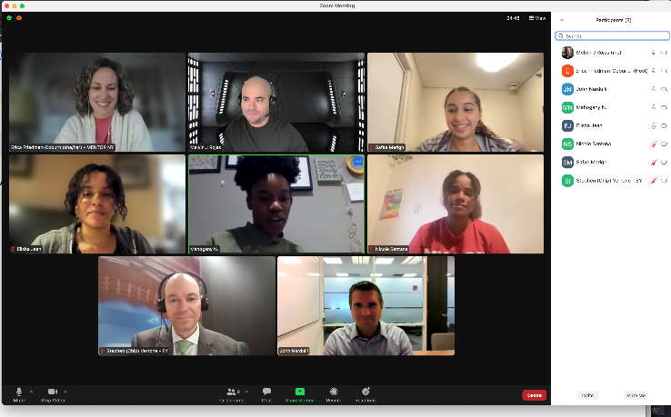
The MENTOR New York Career Readiness Program had eight fellows from attending colleges across the country from diverse backgrounds. They met, engaged, and spoke to 10 executive leaders at different stages of their careers and had a MENTOR New York staff person facilitating their reflection, learning, and discussions about soft critical skills they must be familiar with and develop to have success as the interview and secure future internships and professional experiences. Finally, as CEO of the organization, I scheduled one-to-one meetings with each fellow to answer their questions and discuss their resumes and career interest. Preliminary feedback from fellows and guest speakers has been positive. We plan to begin fellow recruitment in late October and repeat this pilot fellowship program in the Spring of 2023 to continue learning. The hope is to identify emerging practices that can guide the over 1300 mentoring programs in MENTOR New York's portfolio to implement similar programs for the young people they serve.
References:
Braven (2021). How Has COVID-19 Changed the Internship Search and Outcomes for College Students? https://bebraven.org/memo-4-how-has-covid-19-changed-the-internship search-and-outcomes-for-college-students/
Buchert, M. (2021). Reflexive, Reflexivity, and the Concept of Reflexive Design. Dimensions, 1(1), 67-76.
Day, D., Harrison, M., & Halpin, S. (2008) An integrative approach to leader development: Connecting adult development, identity, and expertise New York, NY: Routledge ISBN:978-041596462-3
Siggelkow, N &Terwiesch, C.(2019). The age of continuous connection. Customer Experience. Harvard Business Review. https://hbr.org/2019/05/the-age-of-continuous-connection
Snowden, David. "How Leaders Change Culture through Small Actions." Youtube Video, 1:11:06. July 26, 2016. https://www.youtube.com/watch?v=MsLmjoAp_Dg&t=31s
Tichy, N. M., & Bennis, W. G. (2009). Judgment: How Winning Leaders Make Great Calls (Updated ed. edition). New York: Portfolio.
The National Foundation Study of Online Internship by the Center for Research of College-
Workforce Transitions at UW- Madison (2021).The University of Wisconsin, School of
Education. https://education.wisc.edu/news/new-study-reveals-only-22-percent-of college-students-did-internships-during-pandemic/

