Project#1: Chair of MENTOR Affiliate Advisory Council (MAAC)
Project Abstract
Project Goal
During my tenure as the Chair of the MENTOR Affiliate Advisory Council, I created effective feedback loops and shared leadership opportunities for Executive Leaders in a National Nonprofit Affiliate Network.
DEL Outcomes
1 and 3
Competency Areas of Focus
Organizational Dynamics
Leadership Theory Perspectives
Executive Decision Making
Project Overview
In late 2020, I began my two-year tenure as the Chair of the MENTOR Affiliate Advisory Council for the National Organization, MENTOR, of which MENTOR New York is one of 23 local, statewide affiliates in the network I happen to lead. This nonprofit affiliate network structure is a complex adaptive system. It is a neutral network made up of independent components that, at times, act as a unified whole to learn from experience and adapt to the changing environment,
The purpose of MAAC was to create a place where affiliate leaders partnered with the National Organization on key initiatives that affected the entire affiliate network and the mentoring movement overall. Over the years, it had a reputation of being a mouthpiece to the national organization and not an independent body ideating and challenging some practices that directly or indirectly affected the local affiliates, the network, and the mentoring movement. The following project I engaged in brings focus to DEL program outcomes 1 and 3 with the critical focus areas on organizational dynamics, executive decision-making, and leadership perspectives.
After being on the advisory committee since June 2019, I have assessed several practices that created this perception and some gaps in the local affiliate and national partnership the MAAC could begin to address through practice. This sensemaking process allowed me to identify the challenges and articulate them clearly to the committee to springboard them into action (Weick et a., 2005).
I understood I had to present a clear business case to generate a shared vision and an effective strategy to implement new practices and ways of working for the advisory council. According to Freedman (2003), the exercise of building strategy can only go beyond the executive's need to define their leadership and feed their ego if the momentum of implementation takes hold. That momentum is created by how effectively the executive and senior management team communicate the strategy and followers' level of ownership of the strategy (Freedman, 2003).
Project In Action
AS MAAC Chair, I utilized two of my strengths identified in the Strength Builder Assessment my ability to activate solutions to challenges and influence and motivate others to work towards a shared vision that can make a transformative difference for the stakeholders and the organizations we are working to support.
As I made sense of the identified challenges and the desire my CEO colleagues across the country had to be a part of a more dynamic and inclusive affiliate network, I decided to observe, listen and develop a strategy inclusive of their voice and ideas. I started by presenting the MAAC team with a clear business case that MAAC should become a source for feedback and idea sharing to enhance the partnership between local affiliates and national when trying to address some of the most pressing needs young people were facing nationally, product development, securing funding, and rolling out major initiatives. To do this, I presented a new meeting structure that moved our meeting from 1 hour to 90 minutes and allowed the first 30 minutes to be an ideation and feedback exchange between a selected senior leader from the national office that wanted to present an idea, challenge, or proposal to the affiliate network.
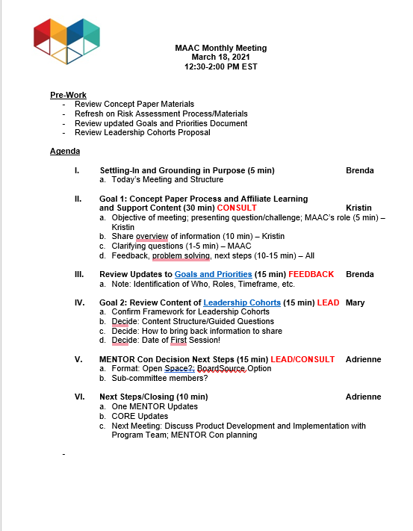

This new meeting format allowed for a more thoughtful and inclusive process in the abovementioned areas while ensuring a natural feedback loop absent in our current work. This combination of sensemaking and relational leadership will enable individuals to work with what they have. Limited resources should not limit action orientation, resourcefulness, opportunities, and purpose. The power of collective thinking and the recombination of resources allows for strategy to be moved forward (Nonaka & Zhu,2012).
They ensured we stayed focused and could measure our success; I created clear goals and objectives of what we would accomplish over the next year to ensure success and that changes were implemented, and this collective process of determining goals allowed for a collective buy-in and support to the members, ensuring success. Shared purpose can drive strategy. Creating legitimacy, agendas, and decision-making models are a few ways shared purpose can help move the strategy along in an organization (Nonaka & Zhu,2012). It helps bring followers together and use the strategy to drive the work and obtain collective desired outcomes. Goals doc
Finally, we shifted our feedback loop strategy to be more inclusive and engage all Affiliate CEOs. We established regional leadership cohorts and had 2 MAAC members CEO lead small groups of their CEO peers to present initiatives, challenges, and opportunities for their informed feedback and ideas. Creating these small cohorts of CEO peers allowed for an environment of psychological safety that allowed CEOs to articulate their ideas, suggestions, and decent honestly and openly. MAAC members were encouraged to present ideas as trends and conversations to be further probed by MAAC members and not personal statements by a particular CEO to promote the psychological safety necessary for honest dialogue and feedback. Research shows that under conditions of psychological safety, employees can share experiences and perceptions of service failures through the efficient interpersonal communication (Chao et al., 2021). This feedback loop strategy allowed for more significant ideation and considerations of threats and strengths to be surfaced that National Senior Leaders may have missed are leading the charge or MAAC members providing information and feedback. Leadership cohort doc
Conclusion
During my tenure as Chair, I successfully implemented these strategies and created sustainable practices that helped institutionalize many of the approaches, allowing the next MAAC chair to have a foundation to tackle the new challenges and opportunities. Our MAAC team had established an effective leadership structure that created a continuous feedback loop that fosters the psychological safety and innovation need for an organization that addresses some of the most pressing needs for young people through mentoring.
Reference:
Chao, R., Zhang, L., Yang, Y. (2021). How the psychological safety of employees influences job performance in the insurance industry? The mediation role of organizational communication and organizational learning. The International Journal of Organizational Innovation. Volume 14, p. 1.
Freedman, M. (2003). The genius is in the implementation. Journal of Business Strategy, 24(2), 26–31.
Nonaka, N. and Zhu, Z. (2012). Pragmatic strategy: Eastern wisdom, global success. New York, NY: Cambridge University Press. ISBN 978-0-521-17314-8.
Sammut-Bonnici, T. & Cooper, G.(2019). Complex Adaptive Systems. Understanding Complex

Systems, Wiley Encyclopedia of Management.

Weick, K., Sutcliffe, K, & Obstfeld, D. (2005). Organizing and the Process of Sensemaking. Organization Science. Vol. 16, No. 4, July–August, pp. 409–421

